**Project Design Phase-II**

**Technology Stack (Architecture & Stack)**

|  |  |
| --- | --- |
| Date | 03 October 2022 |
| Team ID | PNT2022TMID02194 |
| Project Name | University Admit Eligibility predictor |
| Maximum Marks | 4 Marks |

**Technical Architecture:**

The Deliverable shall include the architectural diagram as below and the information as per the table1 & table 2

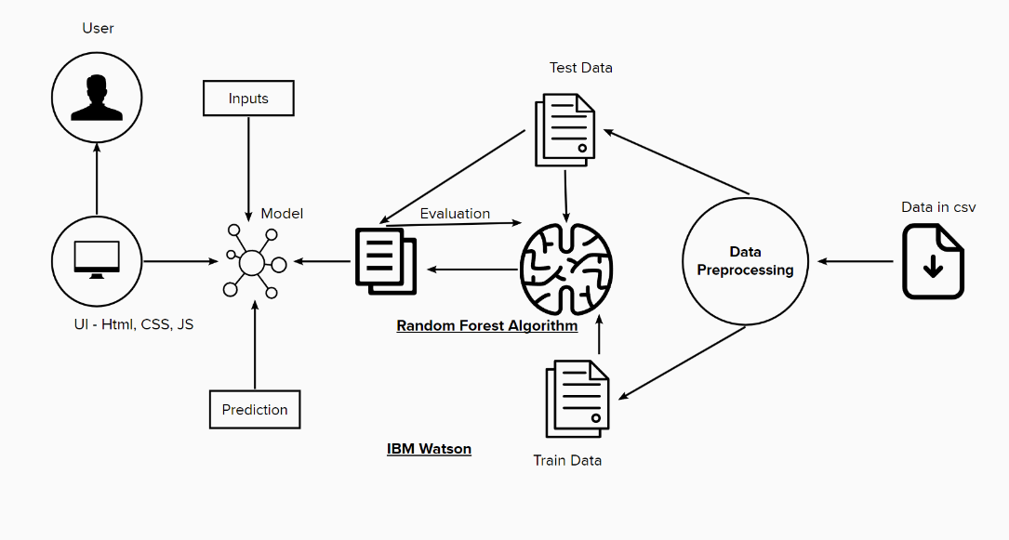

**Table-1 : Components & Technologies:**

|  |  |  |  |
| --- | --- | --- | --- |
| **S.No** | **Component** | **Description** | **Technology** |
|  | User Interface | How user interacts with application e.g.  Web UI, Mobile App, Chatbot etc. | HTML, CSS, JavaScript / Angular Js / React Js etc. |
|  | Application Logic-1 | Logic for a process in the application | Python |
|  | Application Logic-2 | Logic for a process in the application | IBM Watson |
|  | Machine Learning Model | Run Superior ML Models in production | Random Forest |

**Table-2: Application Characteristics:**

| **S.No** | **Characteristics** | **Description** | **Technology** |
| --- | --- | --- | --- |
|  | Open-Source Frameworks | List the open-source frameworks used | Flask |
|  | Performance | Performance of the application | Handle 100 requests per second |